After completing this lab you should be able to:
- Identify the differences between animals, plants, and fungi
- Describe some unique traits found in each of these groups
- Understand how to identify an animal, plant, or fungi
- Group organisms based on similarities and differences
- Be familiar with identification guides

Pre-lab Questions
What is the taxonomic hierarchy?
Taxonomic hierarchy is the arrangement of organisms based on their associations and characteristics.

List the taxonomic hierarchy from most inclusive (biggest groups) to least inclusive (smallest group).
Domain, kingdom, Phylum, Class, Order, Family, Genus, Species

What makes up the scientific name of an organism? Why are scientific names preferred over common names?
The scientific names of plants and animals are arrived at by scientists by employing a system that describes the species and genus of an organism. The first word is the genus while the second is the species. Scientific names re vital because they are help people all over the world to converse definitely about species. The scientific name is better because it is the same across the globe compared to using the common name which is interpreted differently across the world.

Name 5 phyla found in the kingdom Animalia.
Porifera
Cnidaria
Platyhelminthes
Annelida
Mollusca

Name 3 phyla found in kingdom Fungi.
Chytridiomycota
Basidiomycota
Zygomycota

Name 3 phyla found in kingdom Plantae.
Bryophyta
Pteridophyta
Sphenophyta

Lab Instructions:
You will find 10 organisms and classify them as specifically as possible. This will include 4 animals, 4 plants and 2 fungi. You will also include some information commonly included in field journals that may be used to classify these organisms or study where they live (see the tables below). These organisms can include anything you see or find around your house or out on a walk or in your yard (make sure to practice proper social distancing). Once you identify an organism, take a picture of it to insert into the table below. Make sure to only use photos that YOU took. DO NOT pull photos from google images to fill in the chart. You may use any resource you wish to classify the organism and fill in its chart. You will have 2 weeks to complete this assignment.
Here is a good site to get you started on identification:
https://www.backyardnature.net/i-ident.htm#b

Photo
Kingdom and Phylum | Kingdom-Animalia  Phylum-Chordata
Common and Scientific Name | Dog  Canis Lupus Familiaris
Habitat Type | In my house(couch)
Time of Day sighted | 3.35 pm
Current Weather | Weather in my house 70°f low humidity

Photo | 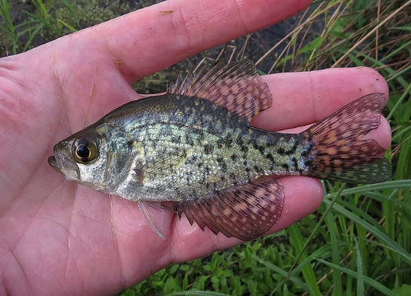
Kingdom and Phylum | Kingdom-Animalia  Phylum- Chordata
Common and Scientific Name | Black crappie fish  Pomoxis nigromaculatus
Habitat Type | Nearby pond
Time of Day sighted | 4.15pm
Current Weather | Weather in near the pond 30°f high humidity

Photo | 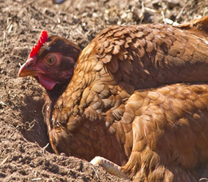
Kingdom and Phylum | Kingdom-Animalia  Phylum-Chordata
Common and Scientific Name | Chicken  Gallus gallus domesticus
Habitat Type | In the field at my neighbors place
Time of Day sighted | 12.21 pm
Current Weather | Sunny 25°f low humidity

Photo | 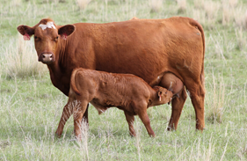
Kingdom and Phylum | Kingdom-Animalia  Phylum-Chordata
Common and Scientific Name | Cattle  Bos taurus
Habitat Type | In the fields
Time of Day sighted | 1.20 pm
Current Weather | Sunny 25°f low humidity

Photo | 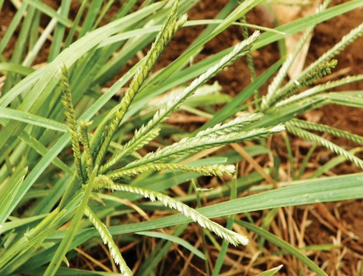
Kingdom and Phylum | Plantae  Spermatophyta
Common and Scientific Name | Grass  Poaceae
Habitat Type | Out in the field
Time of Day sighted | 9.30 AM
Current Weather | Weather in the field 19°f high humidity

Photo | 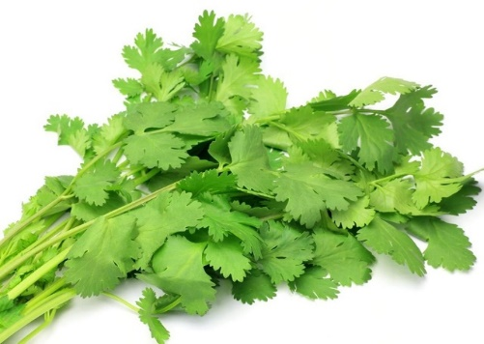
Kingdom and Phylum | Plantae  Spermatophyta
Common and Scientific Name | Coriander  Coriandrum sativum
Habitat Type | Home garden
Time of Day sighted | 10.42 am
Current Weather | Sunny 15°f high humidity

Photo | 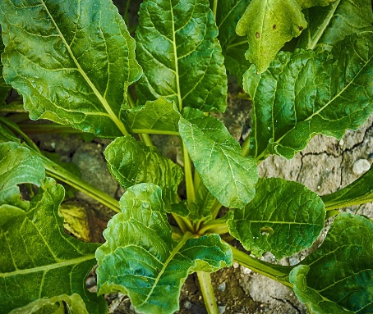
Kingdom and Phylum | Plantae  Spermatophyta
Common and Scientific Name | Spinach  Spinacia oleracea
Habitat Type | Home garden
Time of Day sighted | 12.30 PM
Current Weather | Sunny 25°f low humidity

Photo | 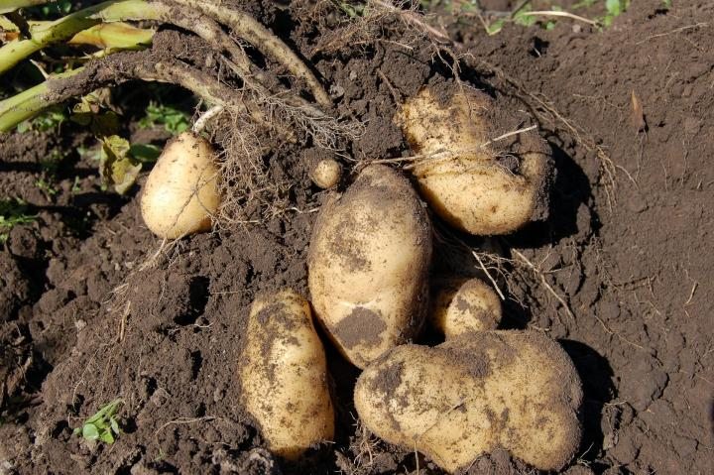
Kingdom and Phylum | Plantae  Tracheophyta
Common and Scientific Name | Potato  Solanum tuberosum
Habitat Type | Home Garden
Time of Day sighted | 2.05 pm
Current Weather | Sunny 35°f

Photo | 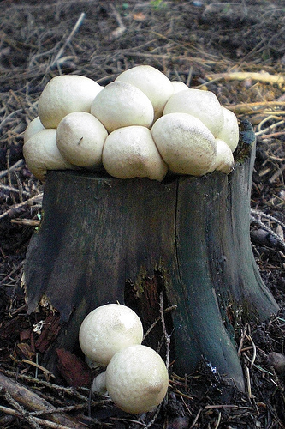
Kingdom and Phylum | Fungi
  Basidiomycota
Common and Scientific Name | White button mushroom  Agaricus
Habitat Type | Forest
Time of Day sighted | 11.30 am
Current Weather | Weather in the forest 20°f high humidity

Photo | 
Kingdom and Phylum | Fungus  Sac Fungi
Common and Scientific Name | Black mold  Stachybotrys chartarum
Habitat Type | Outside in the yard
Time of Day sighted | 5.00 pm
Current Weather | Weather in the yard 22°f windy

If you have any questions or assignments in the future please contact me directly at +1(872) 703-4237. Thank you

